AWS Lambda & API Practice Tasks
Title:
Create Your First Lambda Function
Objective:
Create a new AWS Lambda function to run code in a serverless, event-driven environment with minimal infrastructure management.
Prerequisites:
- AWS Console
- LAMBDA
- Runtime
- IAM role
Step by Step Implementation:
Login to AWS Console and Search for lambda service in search bar and click on create a function
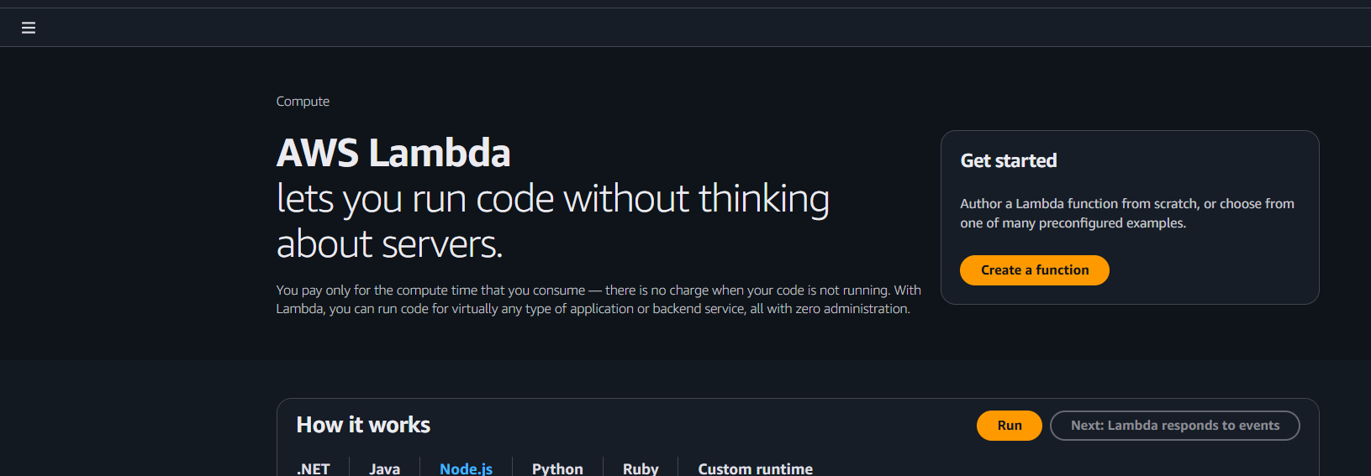

Select the options and provide a name to function and select the runtime as python,java,nodejs etc and continue
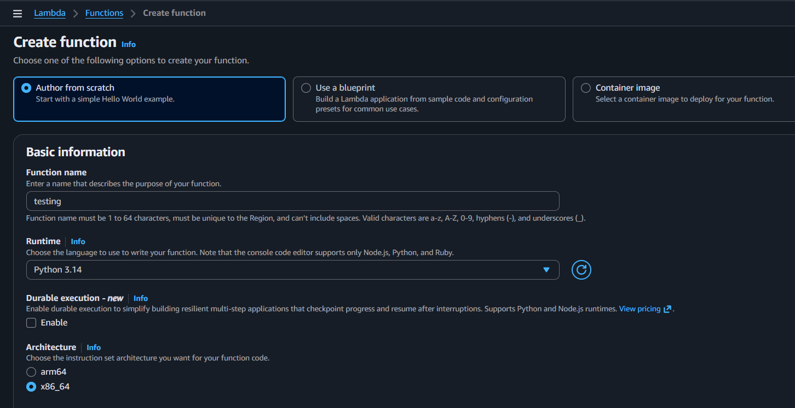
IAM role can be selected if any exist or can also create new one
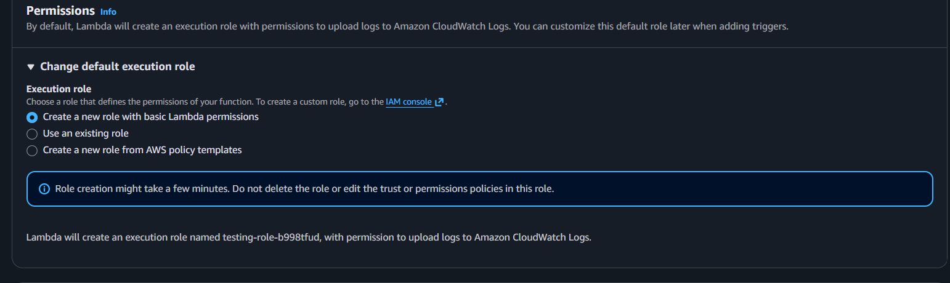
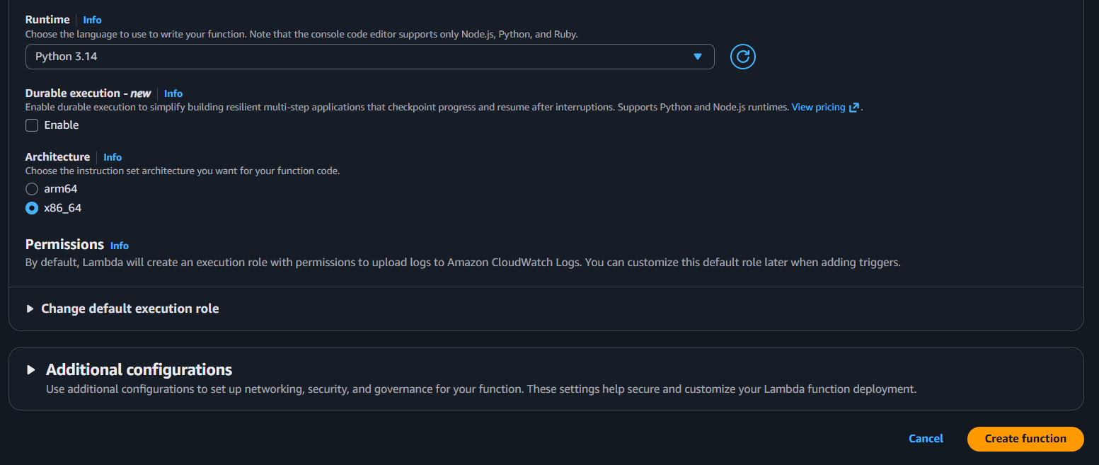
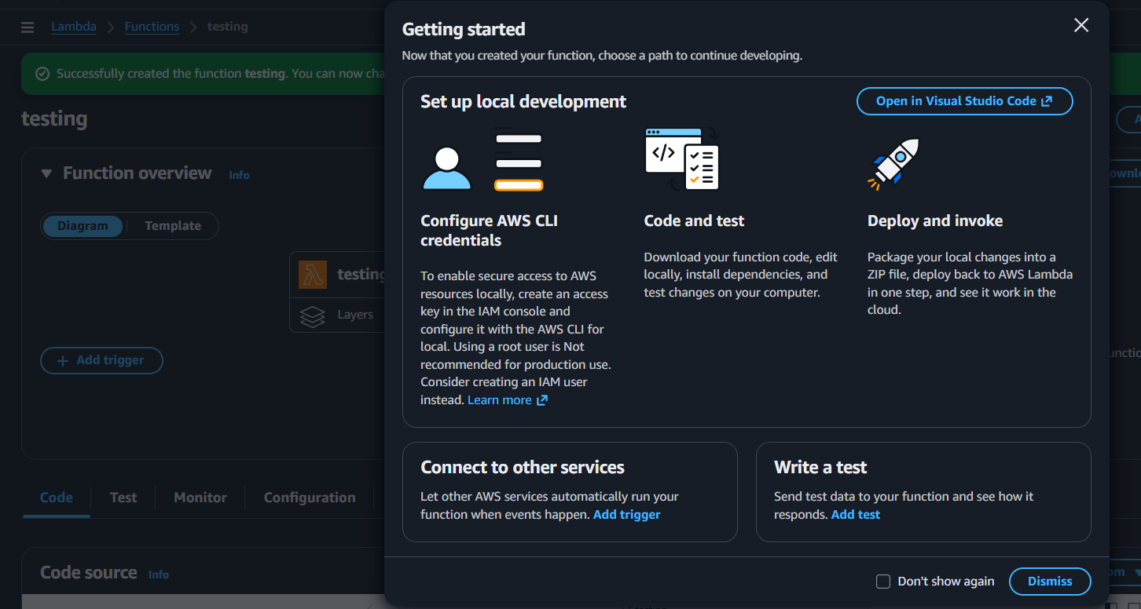
That’s how a lambda function has been created
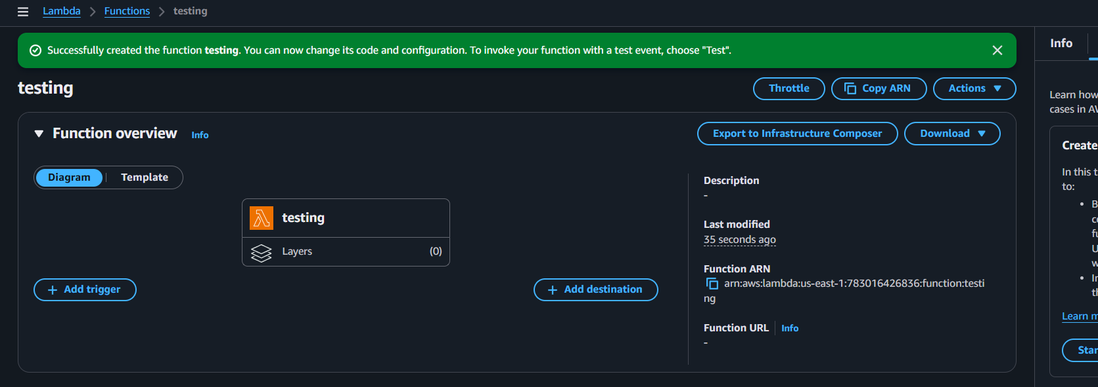
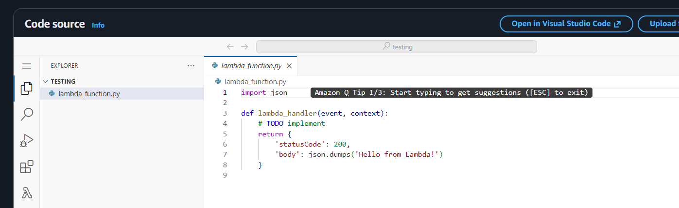
Conclusion:
Lambda function deployed successfully, enabling scalable, cost-efficient automation triggered by events.
Title:
Invoke Lambda Manually
Objective:
Manually invoke an AWS Lambda function to test execution, validate logic, and ensure correct event handling without relying on automated triggers.
Prerequisites:
- AWS
- Lambda function
- Json or python script
Step by Step Implementation:
As you already launched a function click on the function and provide a name to test event and continue by clicking in TEST
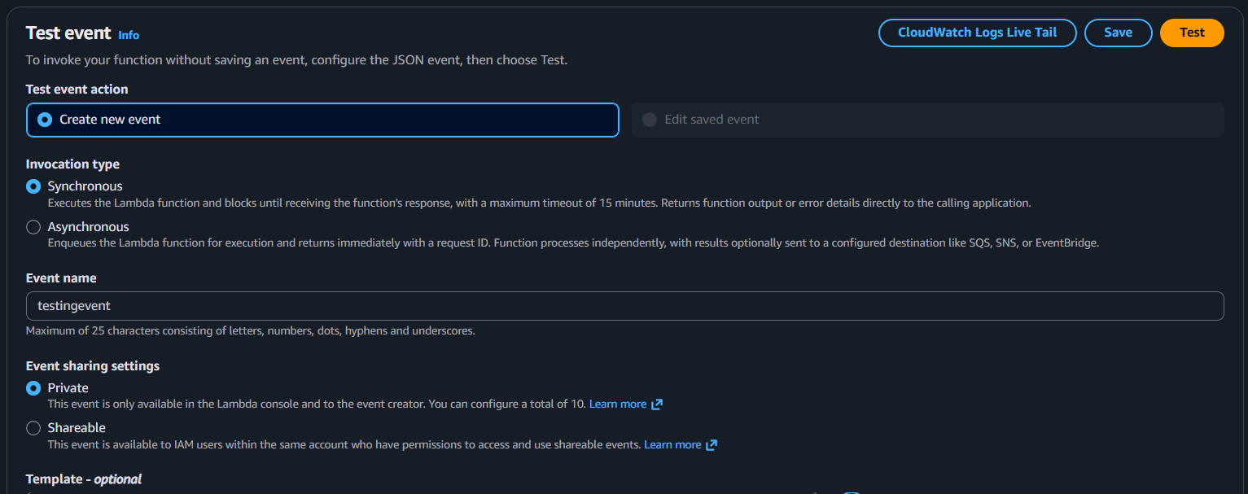
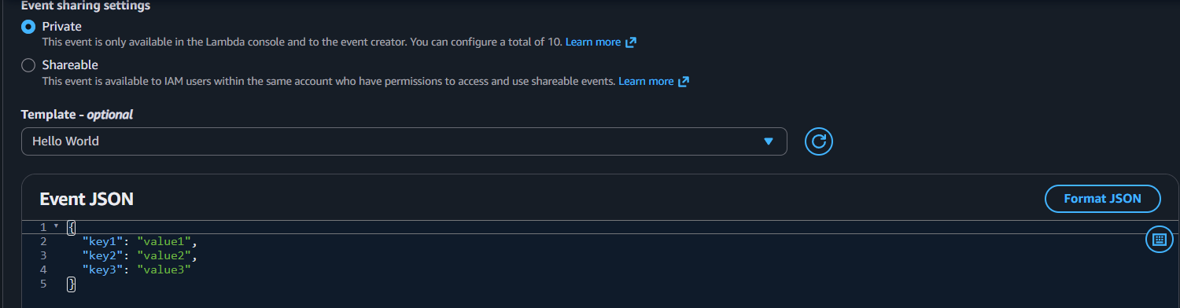

That’s how we invoked lambda function manually
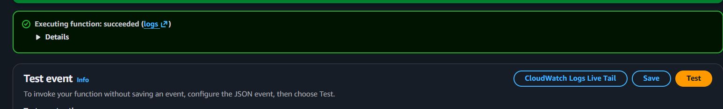
The details about the test and time taken execution of process
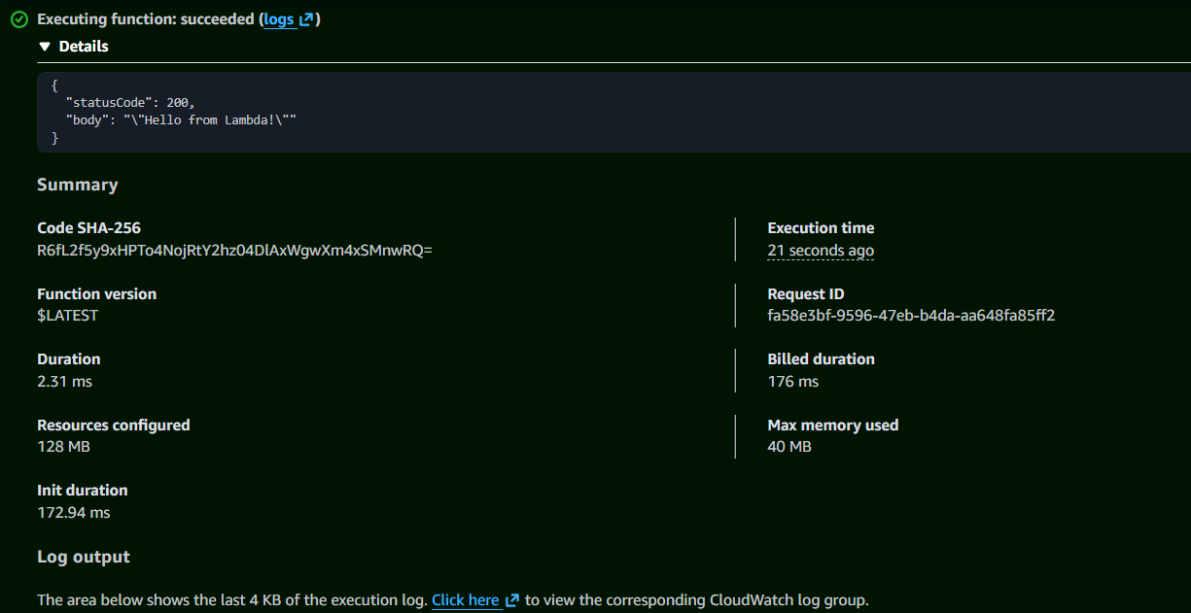
Click on logs to see the logs in cloud watch
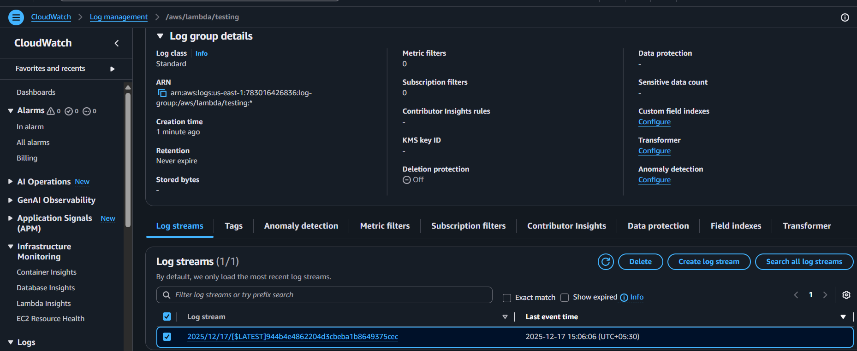
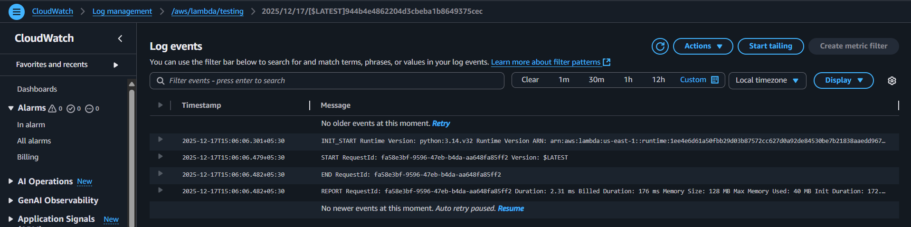
Conclusion:
Lambda function was successfully invoked manually, confirming its code runs as expected and processes events correctly.

Title:
Connect Lambda with API Gateway
Objective:
Connect an AWS Lambda function with API Gateway to expose it as a RESTful or HTTP endpoint, enabling external clients to securely invoke the function via standard API requests.
Prerequisites:
- Aws
- Lambda
- API
Step by Step Implementation:
Navigate to API gateway and click on create
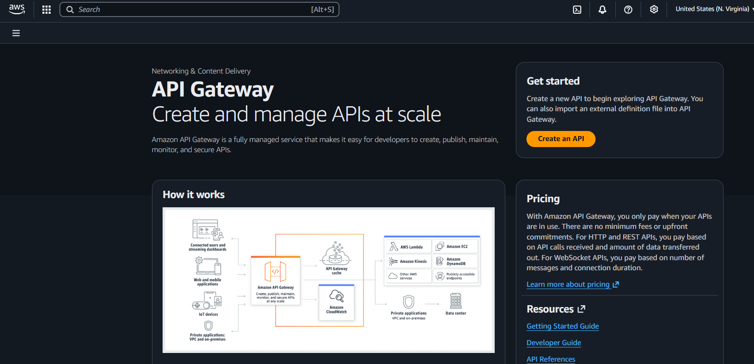

Select HTTP API and Continue
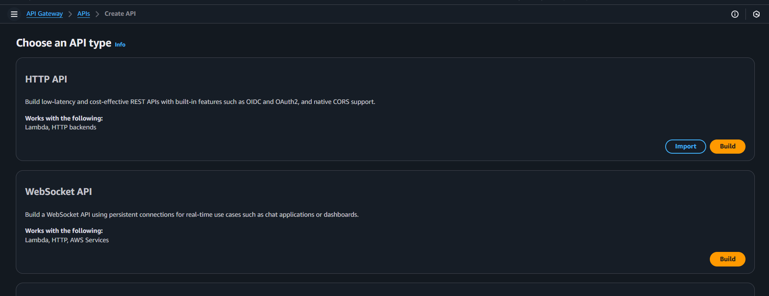
Provide the name and click on next
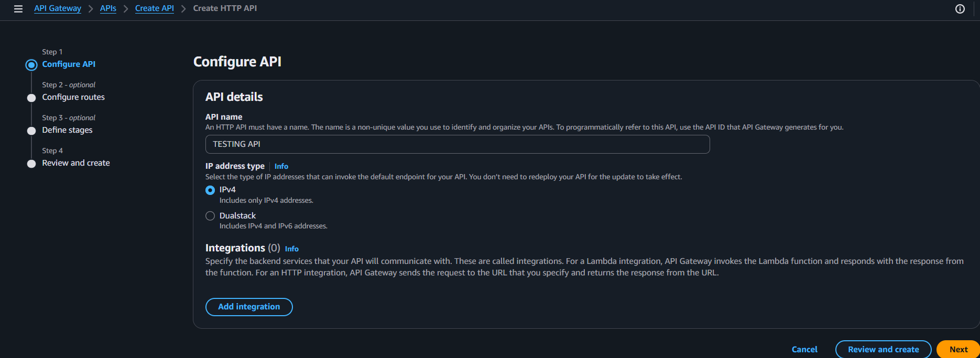
Select the lambda function in integrations tab so that we are mapping lambda and API
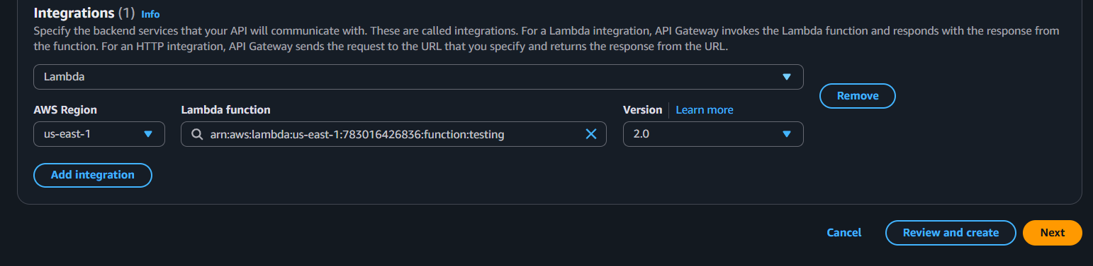

Provide the routes like same in mentioned below and save
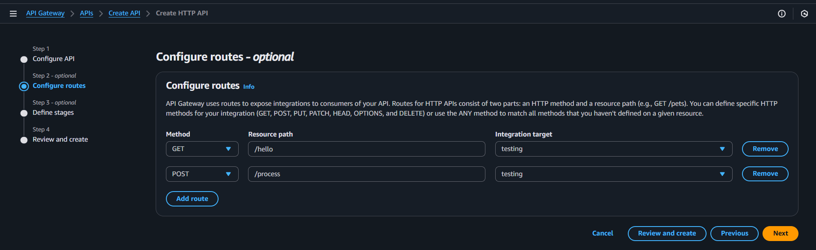
Also create a default stages or you can create your own
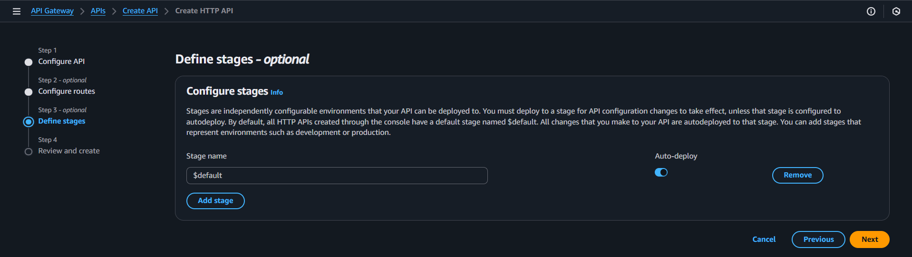
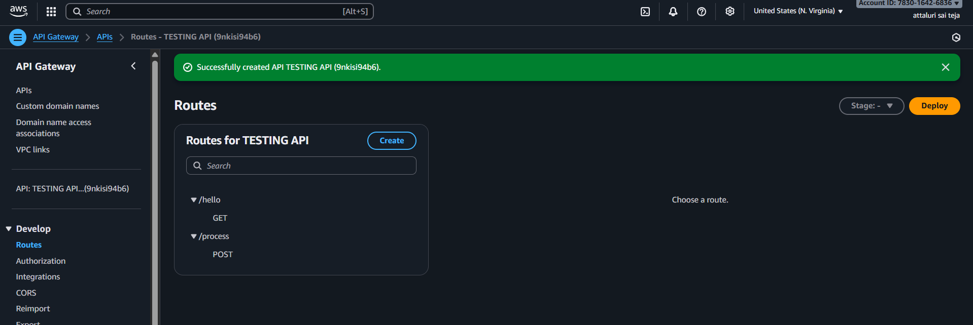
Now everything is created now we need to test in web browser
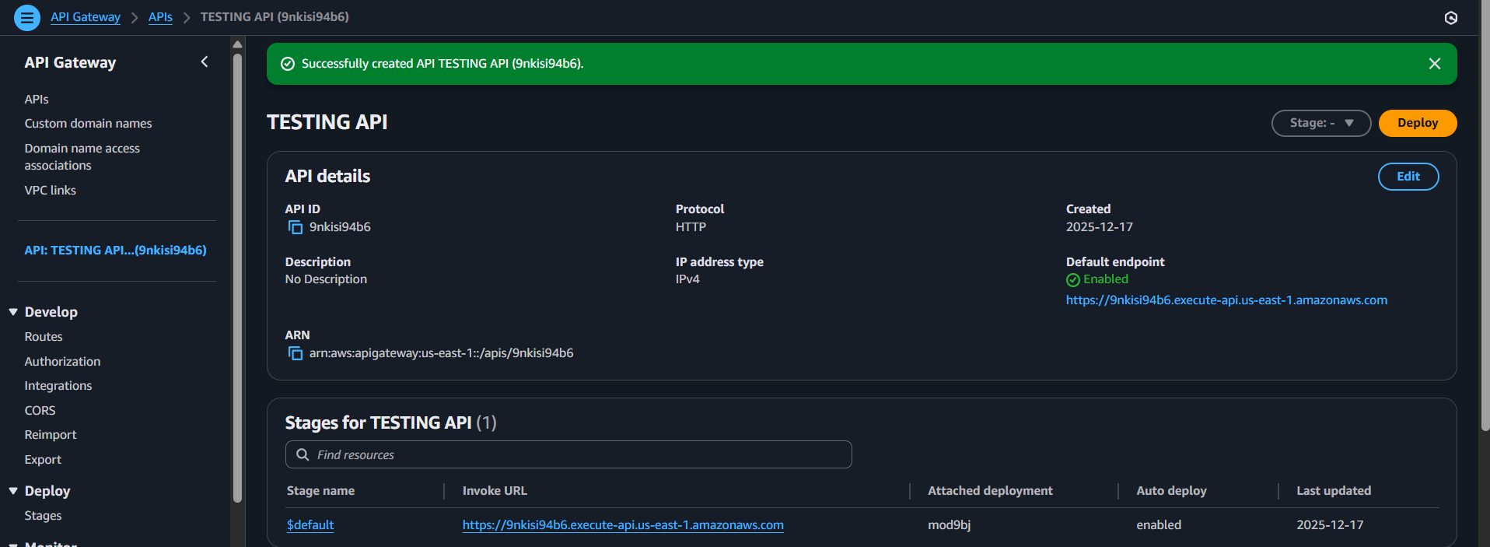
I copied the link and pasted in web browser and git bash but I encountered an error.
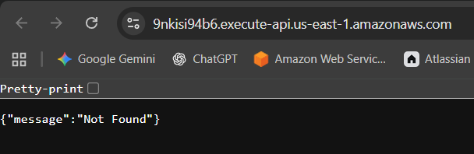
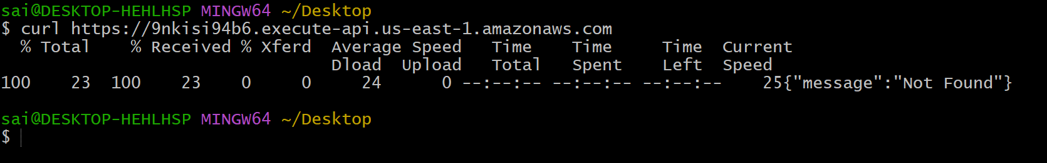
After doing many things that I know that the path which I was given in the browser is incorrect as my path is in stages so that I had faced an error
The Not Found error is typically caused by incorrect URL, method mismatch, or missing route. Once corrected, your Lambda should respond as expected.
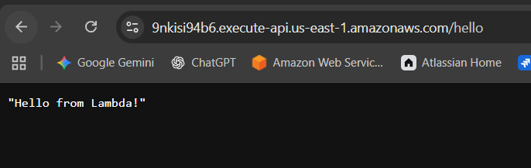
Conclusion:
Lambda is now publicly accessible via API Gateway. You can test, monitor, secure, and scale it as needed.

Title:
Lambda Triggered by S3 Upload
Goal: Event-driven Lambda
Objective:
Configure an AWS Lambda function to be automatically triggered by an S3 file upload event, enabling real-time processing of newly added objects.
Prerequisites:
- AWS
- S3
- LAMBDA
- API
- Cloud watch
Step by Step Implementation:
Create an s3 bucket by providing an unique name
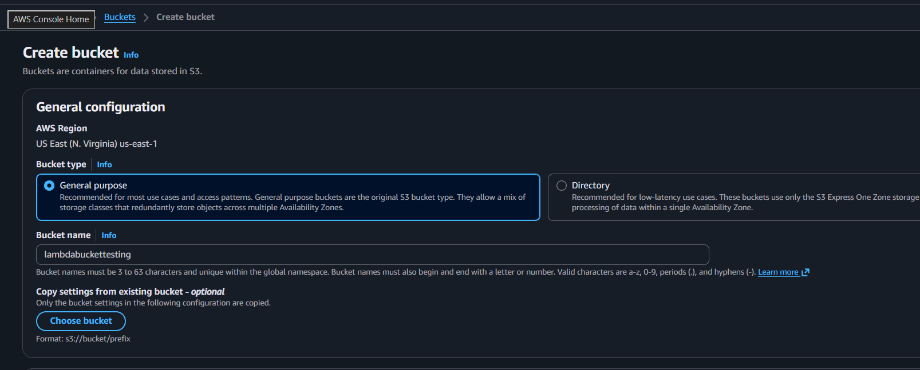
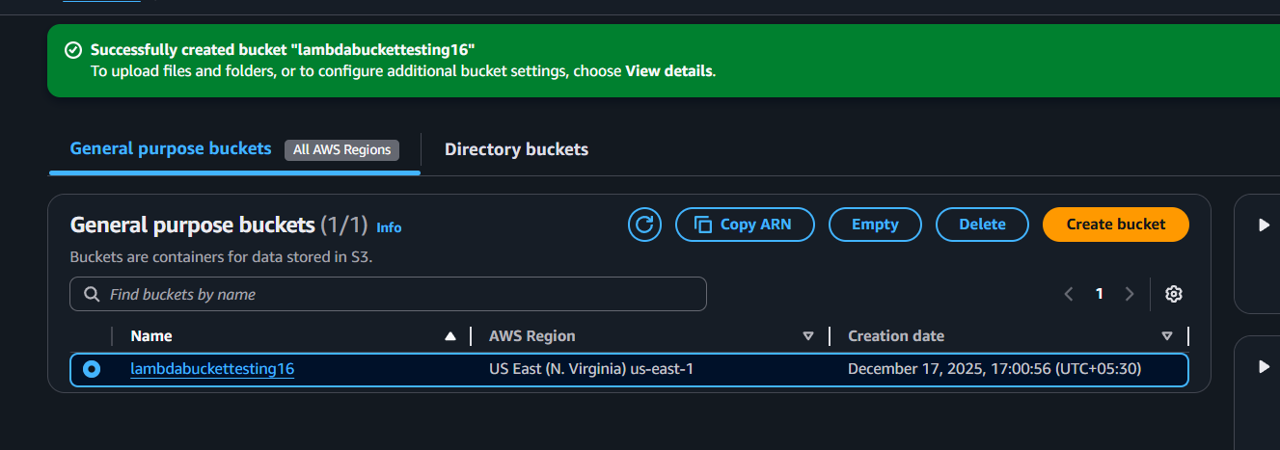
Insert a object into the s3 bucket just for verification
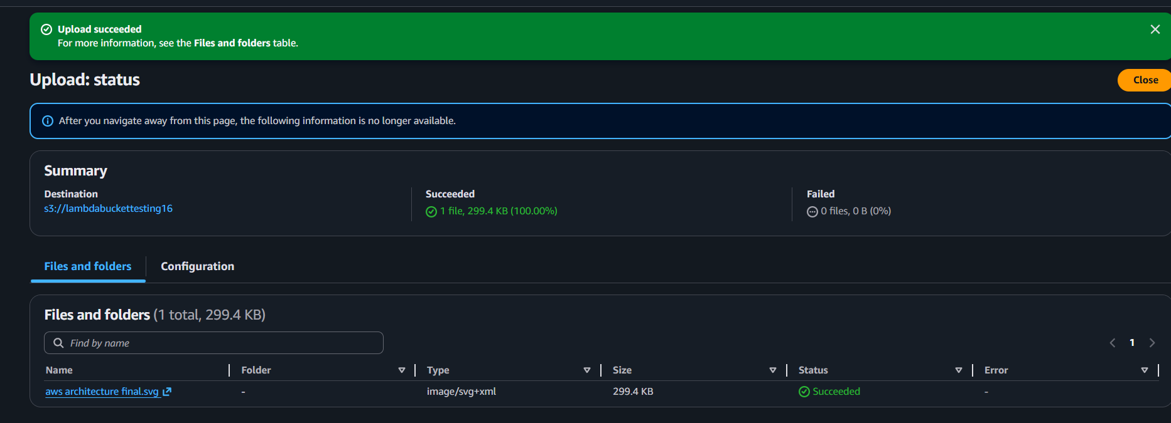
Now again navigate to lambda and add the trigger by selecting s3 and bucket name then save
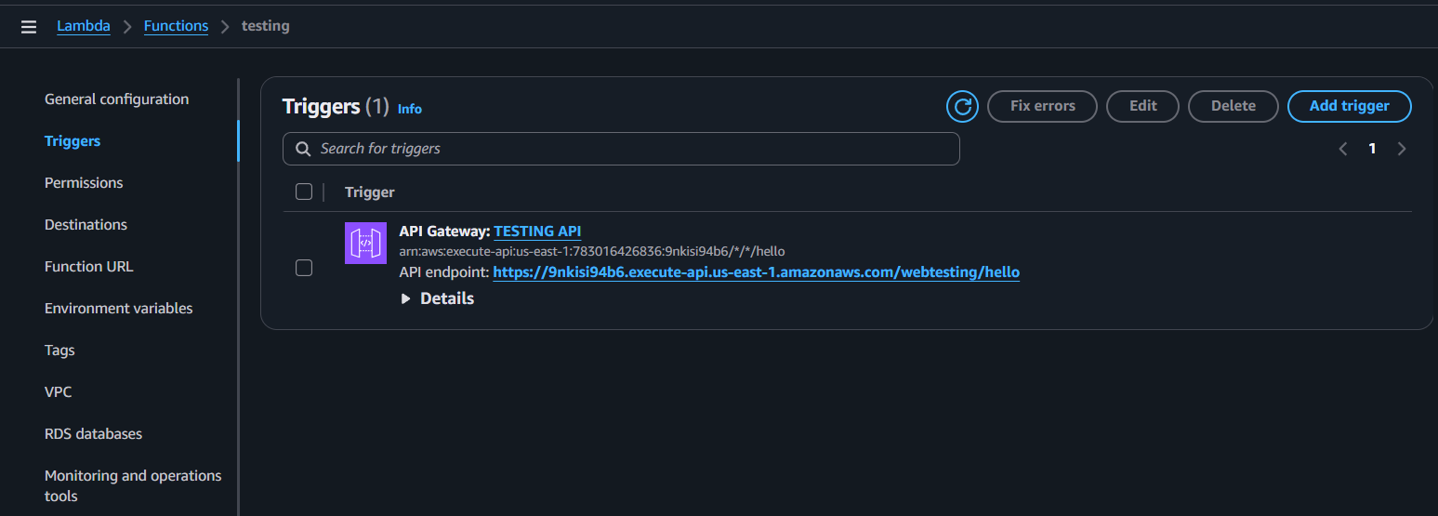
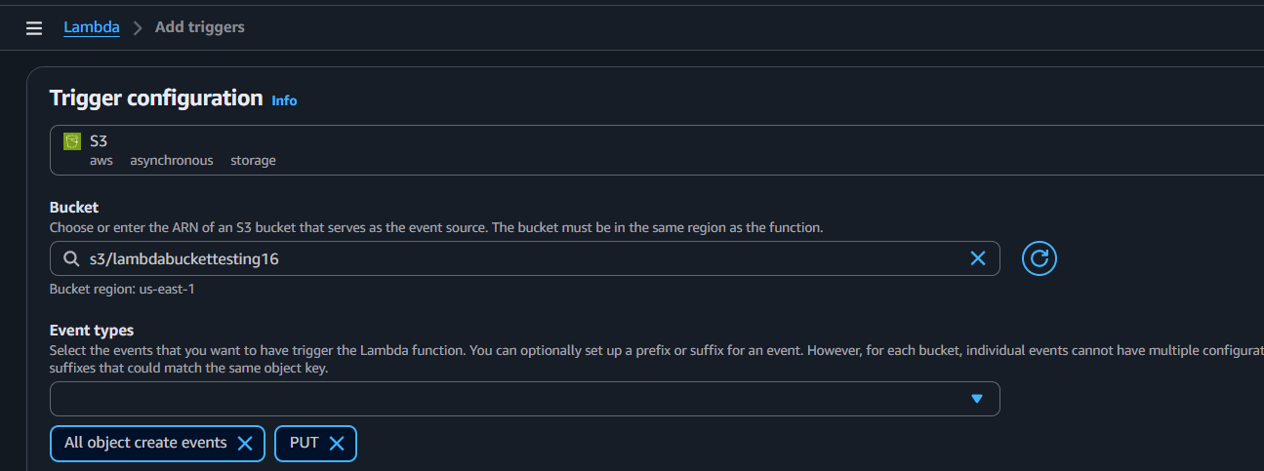

Successfully s3 bucket will be triggered by lambda and now again add some objects in s3 for validation
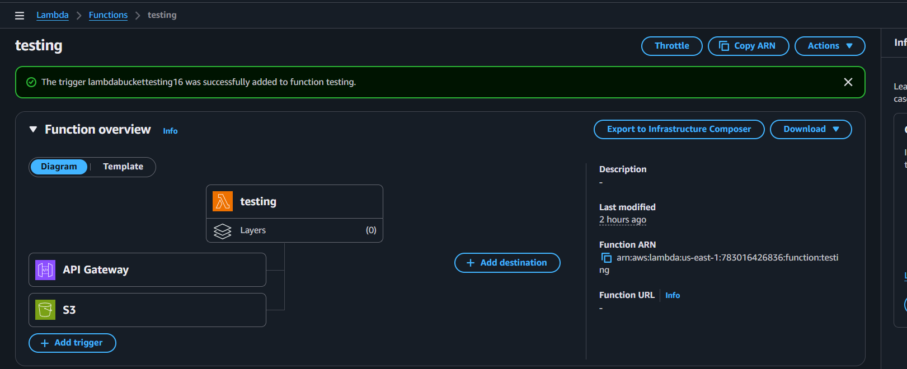
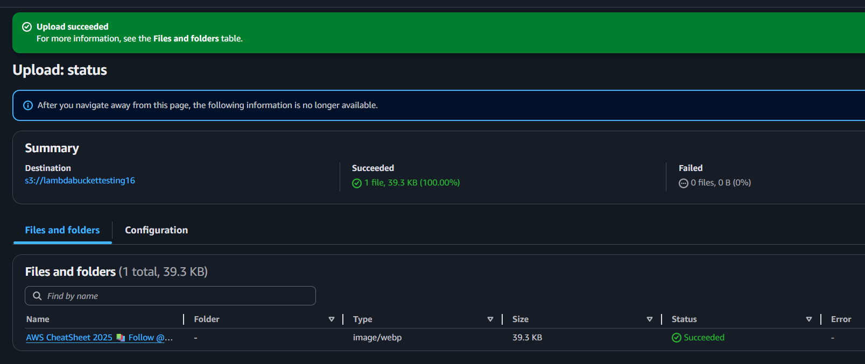
When I am adding new object to s3 a log stream has been created
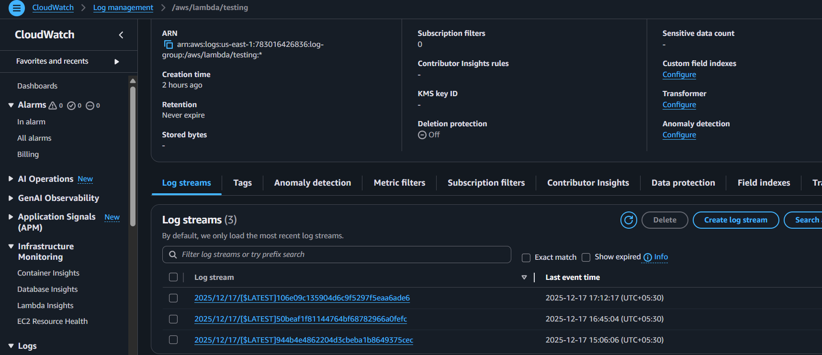
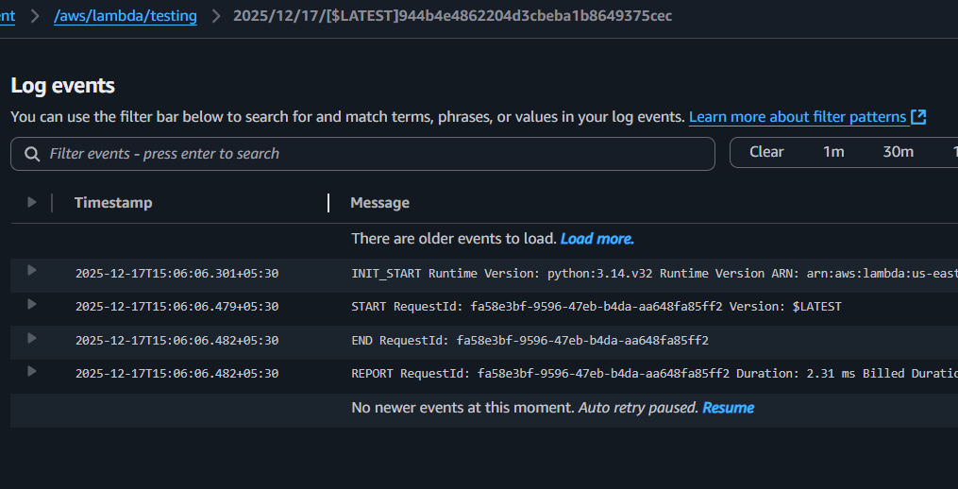
Conclusion:
Lambda was successfully linked to S3, allowing automatic invocation whenever a new file is uploaded to the specified bucket.

Title:
View Logs in CloudWatch
Goal: Debug Lambda
Outcome: monitoring & debugging
Objective:
View AWS Lambda execution logs in CloudWatch to monitor function activity, debug issues, and validate that triggers (like S3 uploads or API Gateway calls) are working correctly.
Prerequisites:
- Lambda
- S3
- Cloud watch
Step by Step implementation:
In the Lambda navigate to code section and replace the python code as shown in below picture and click on deploy
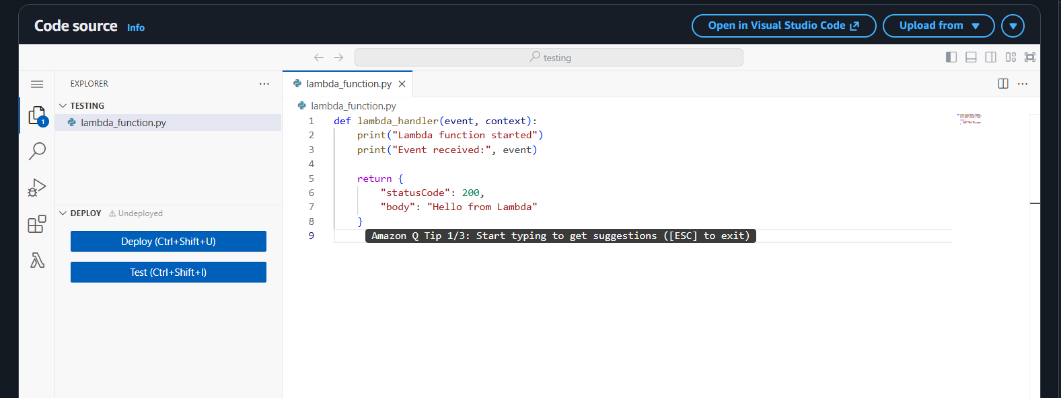
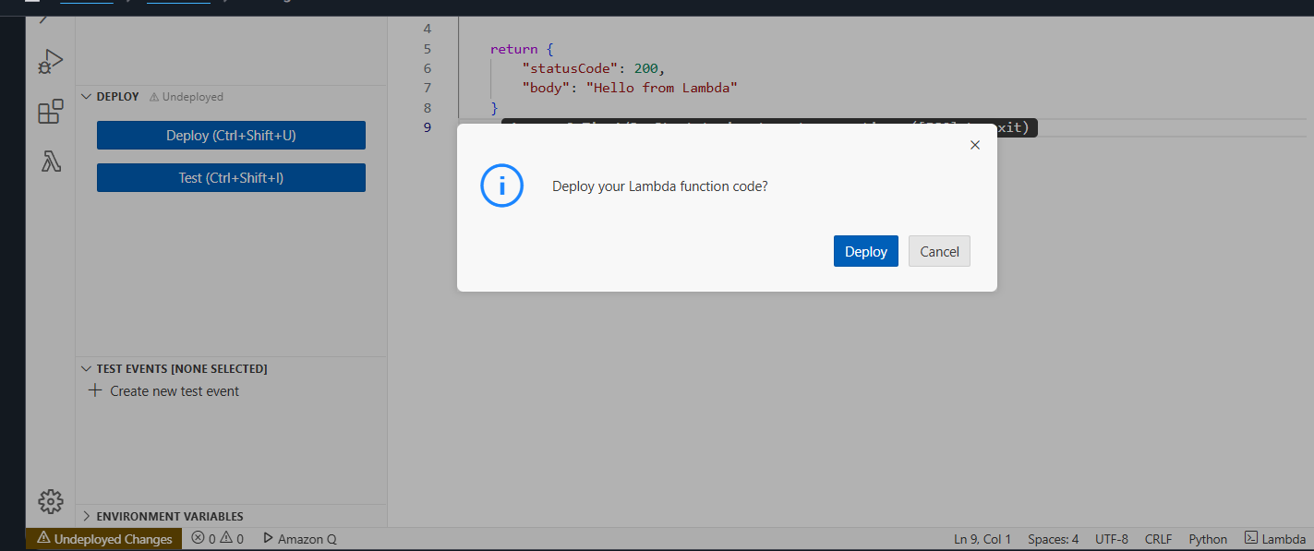
Successfully Deployed
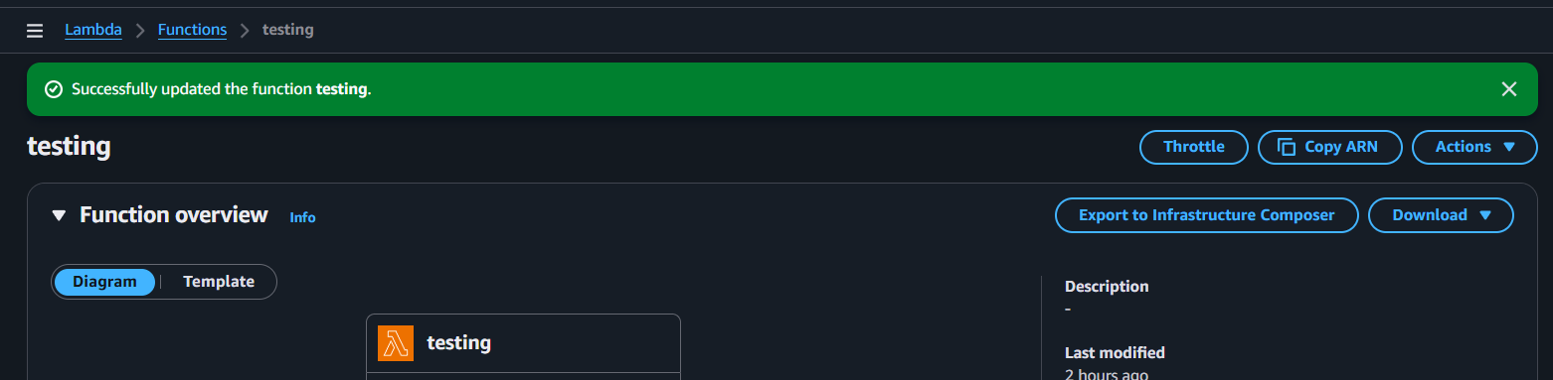
Again refreshing the link to create some logs in cloud watch
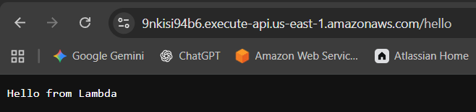
Then a new logs are created and opened them and verified 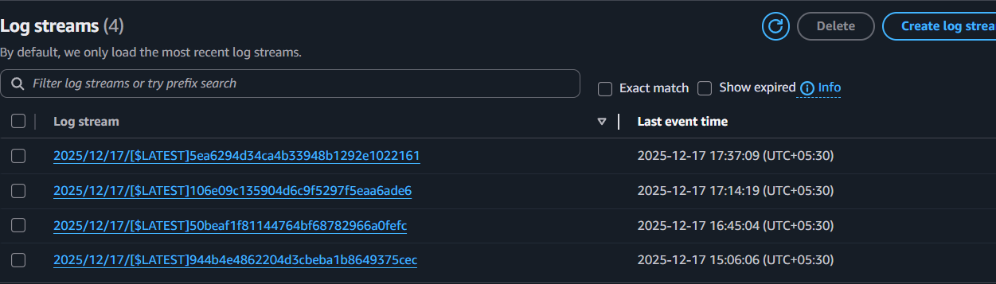
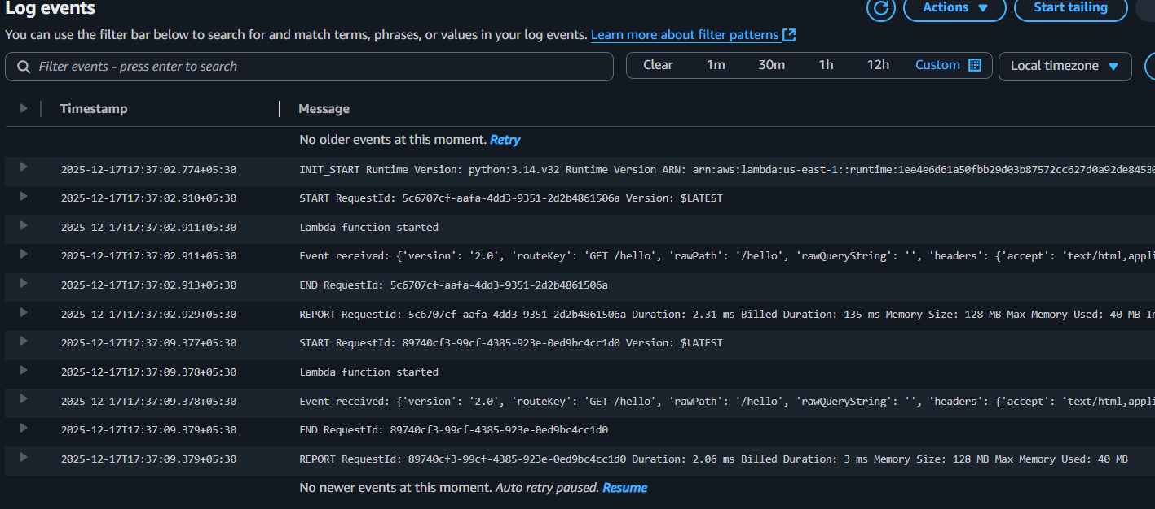
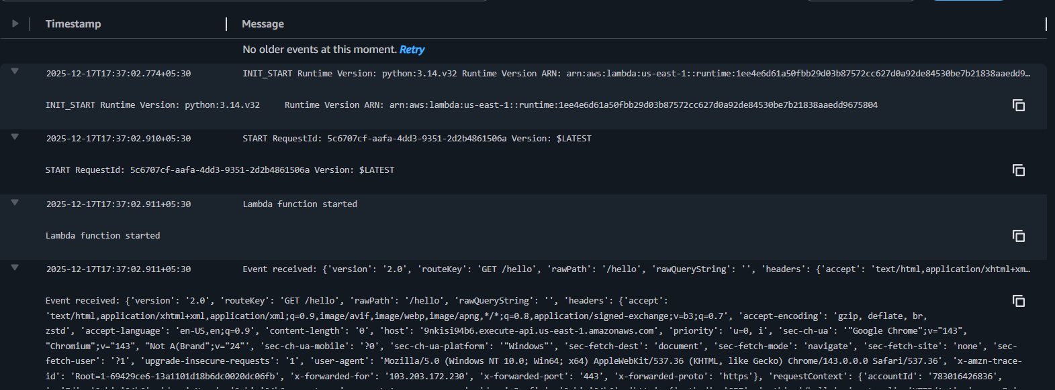
Conclusion:
CloudWatch logs were successfully accessed, confirming Lambda executions, event payloads, and any errors or outputs for troubleshooting and validation

Title:
Task 6: Cold Start vs Warm Start
Goal: Understand Lambda lifecycle
Objective:
Understand the difference between Cold Start and Warm Start in AWS Lambda to optimize performance and reduce latency in serverless applications.
Prerequisites:
- Lambda
- API
Step by Step Implementation:
Attach the new global variable python script in the code source and deploy it
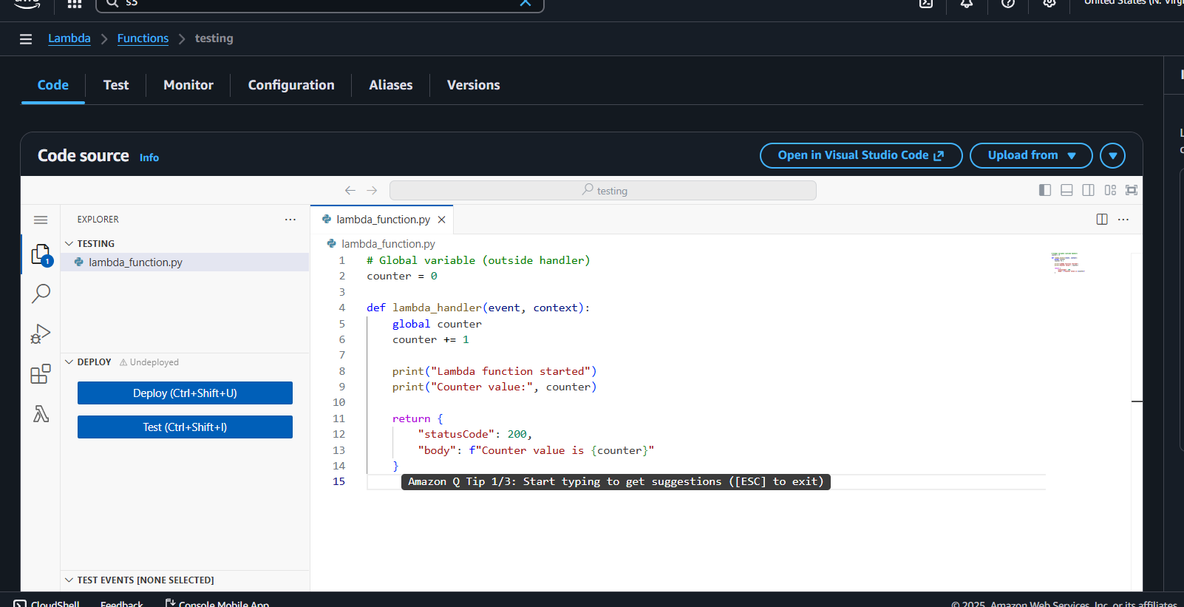
Using the api link again check on browser
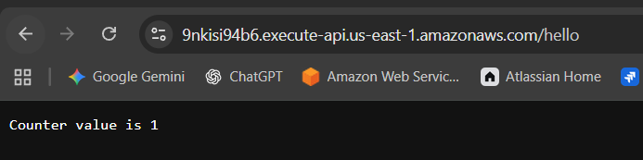

But it was warm start so that the value is increasing or else as a cold start we will get 0 every time
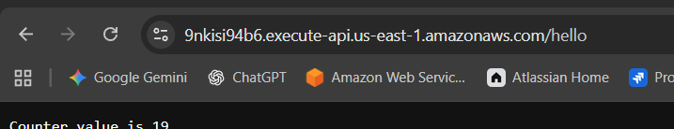
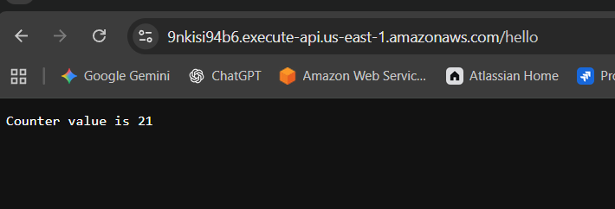
Again navigate to logs and verified the logs
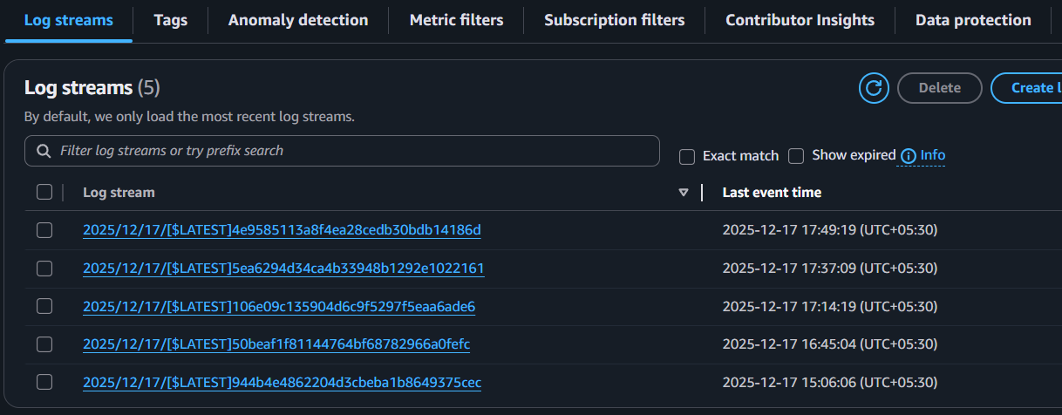
Cold Start:
Create container → Load runtime → Run code → Freeze
Warm Start:
Reuse container → Run handler → Freeze
Changed the code again it was from cold start

Only once init has been happened every time the user requested and server delivered by warm start
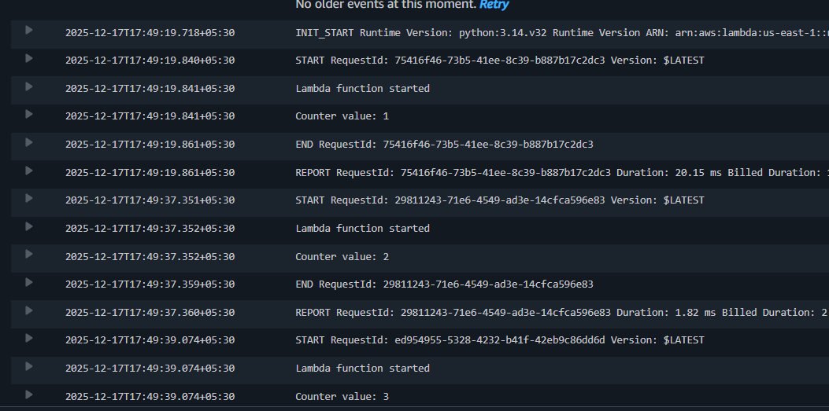
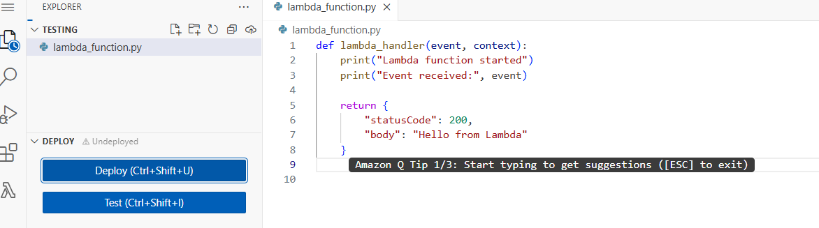
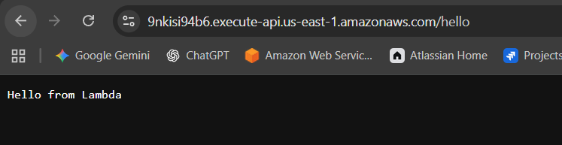

It also had separate log groups because of a cold start
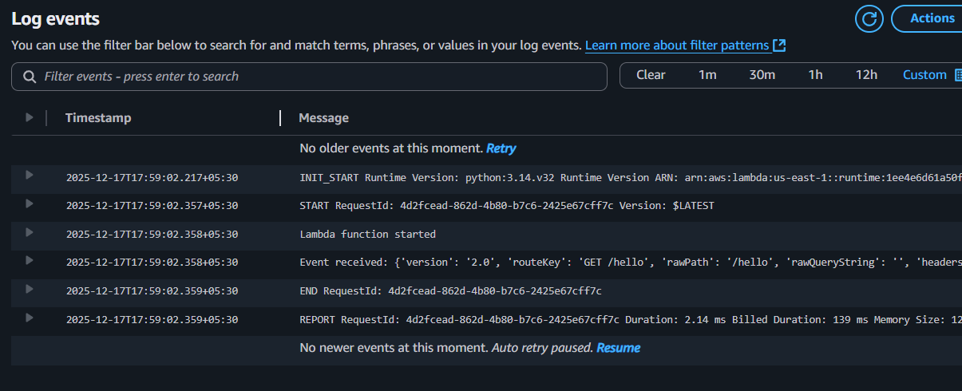
Conclusion:
Cold starts occur when Lambda initializes a new execution environment, causing extra latency, while warm starts reuse an existing environment for faster responses. Knowing this distinction helps design efficient, low-latency serverless workloads.

Title:
Add IAM Permissions (Lambda Accessing S3)
Goal: Secure Lambda access
Outcome: security basics
Objective:
Add the necessary IAM permissions so that AWS Lambda can securely interact with other AWS services (e.g., S3, DynamoDB, CloudWatch). This ensures the function has the correct execution role and policies attached to perform its tasks
Prerequisites:
- IAM
- LAMBDA
- S3
- API
Step by Step implementation:
In my case I used the same bucket, navigate to buckets and upload the objects
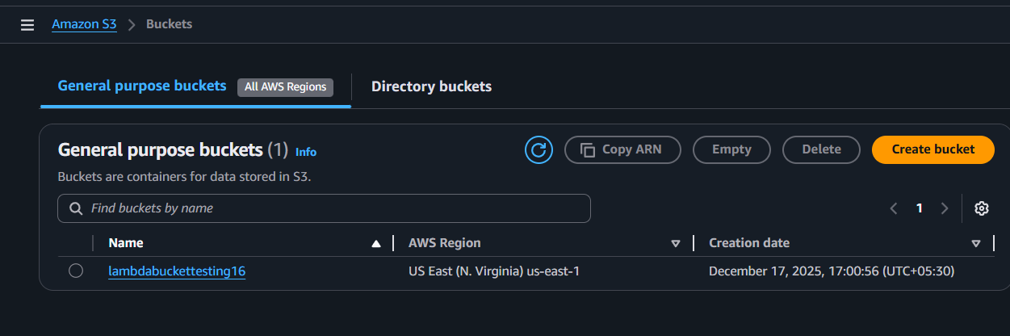

Verified the objects in the bucket
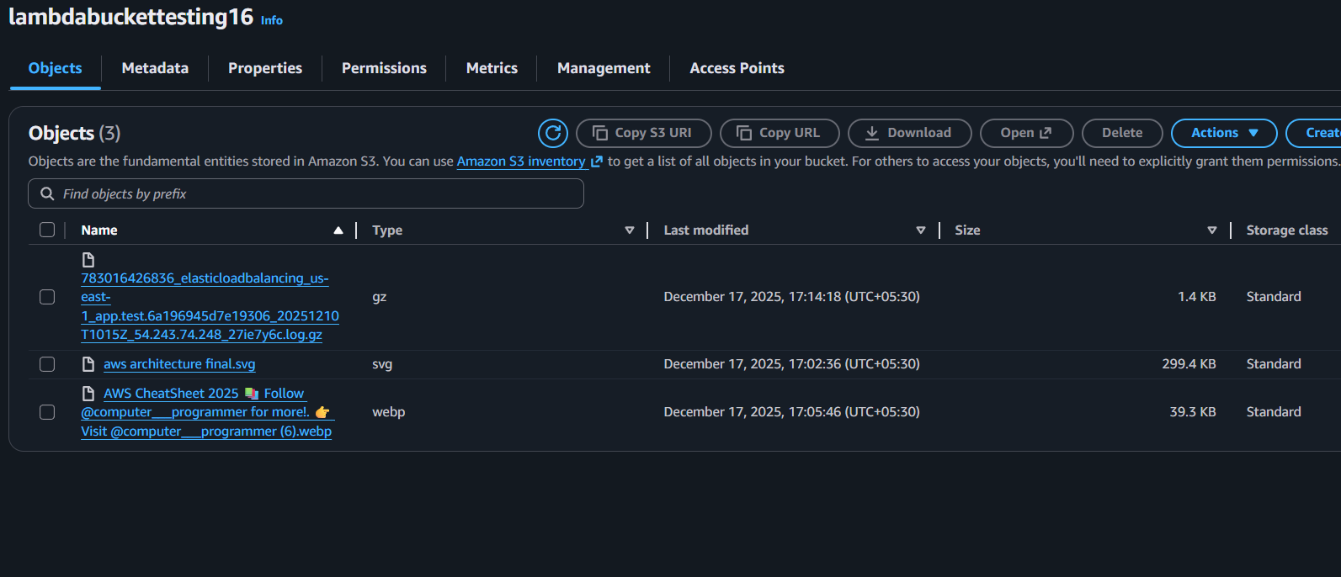
Again navigate to lambda and select configurations and select permissions tab
And click on role name link to navigate to IAM
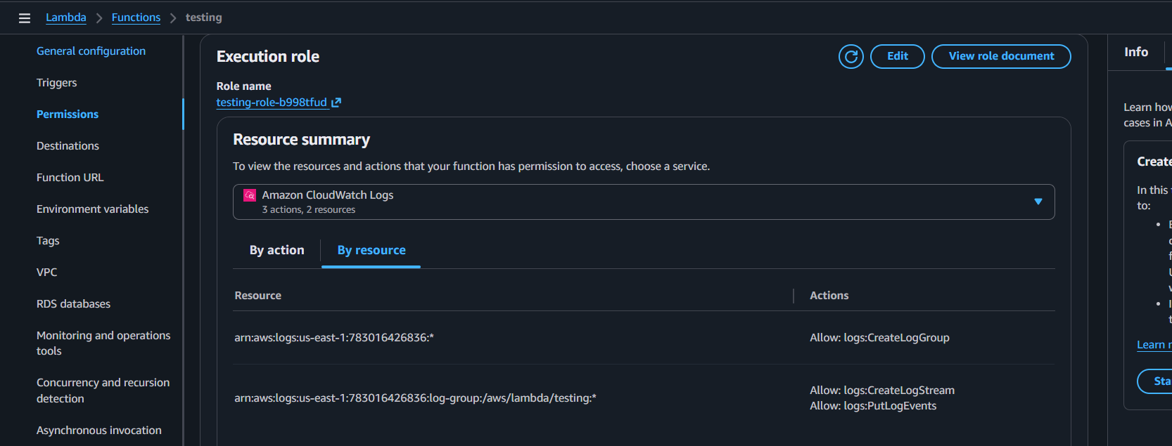
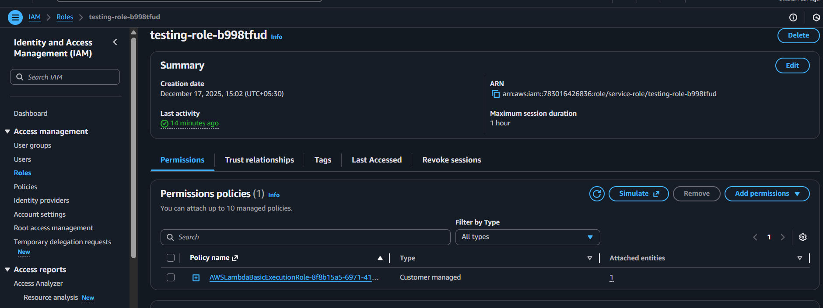

Add S3 read access and save
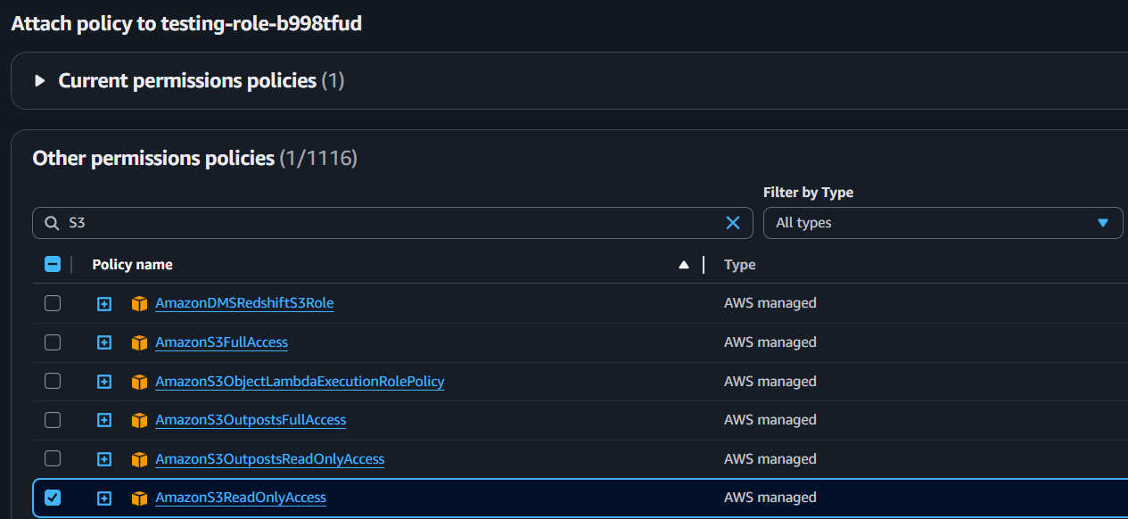
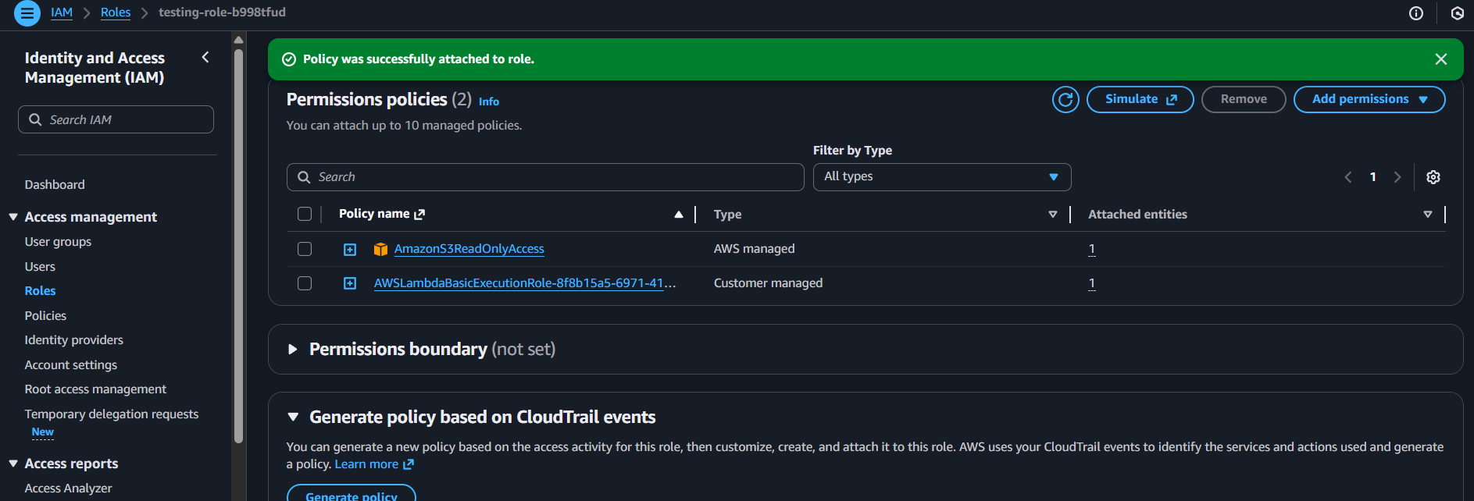
Update the code in lambda
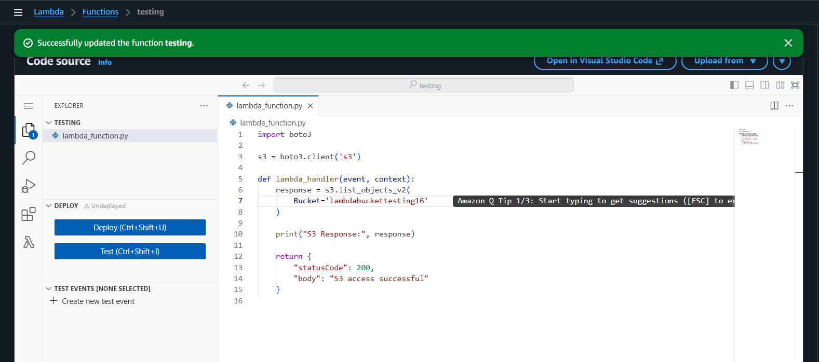

With the API link verify in browser
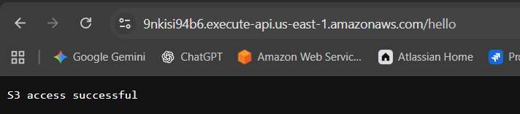
And verified the logs in cloud watch
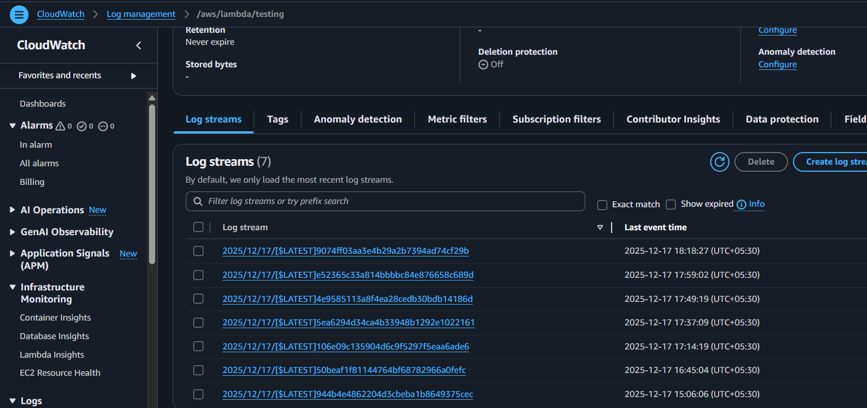
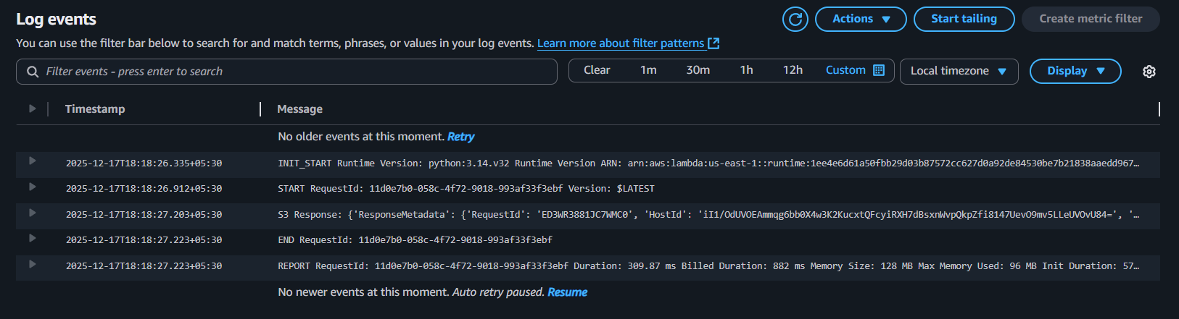
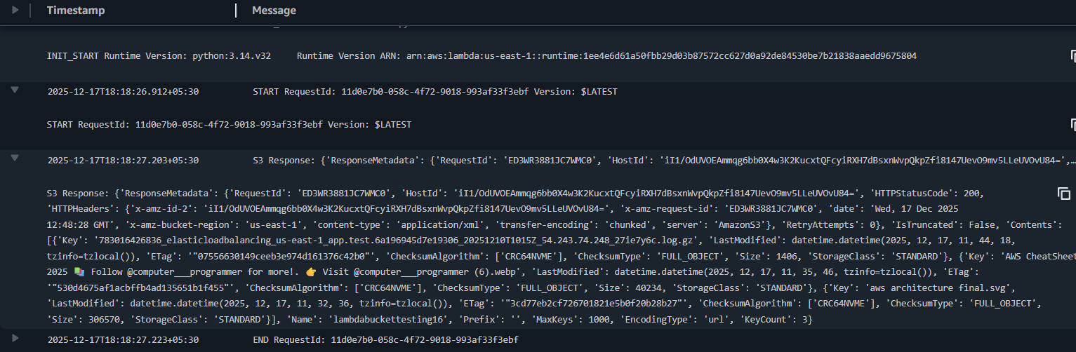
Conclusion:
IAM permissions were successfully added to the Lambda execution role, enabling secure access to required AWS resources while following the principle of least privilege.
Overall Summary
The completion of AWS Lambda Tasks 1 to 7 provides a comprehensive understanding of serverless application development using AWS Lambda. These tasks collectively demonstrate how Lambda functions are created, triggered, monitored, optimized, and securely integrated with other AWS services without managing servers.
Through these tasks, we learned how to create and deploy a Lambda function and invoke it using different methods such as manual test events, API Gateway, and service-based triggers. The integration with API Gateway showed how Lambda can function as a backend service capable of handling HTTP requests. Event-driven execution was demonstrated by connecting Lambda with AWS services, highlighting real-time, automated processing.
Logging and monitoring using Amazon CloudWatch helped in understanding Lambda execution behaviour, debugging errors, and analysing performance metrics. The Lambda execution lifecycle was explored through cold start and warm start behaviour, showing how execution environments are reused and how global variables may persist across invocations.
Security and access control were addressed by configuring IAM roles and permissions, enabling Lambda to interact securely with other AWS services while following the principle of least privilege. Overall, these tasks illustrate how AWS Lambda enables scalable, cost-effective, and event-driven applications with minimal operational overhead

